# **JavaScript Arrays**

An array is an ordered list of values.

Each value is called an element, and each element has a numeric position in the array, known as its index

 the first element is at index 0,

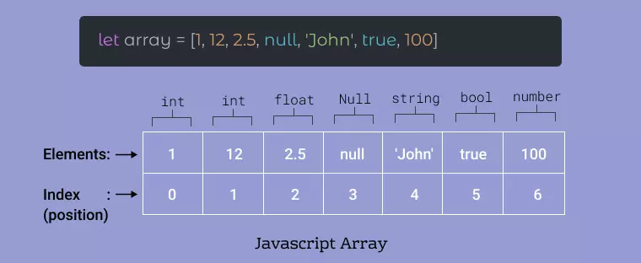

### **Create Array using Literal**

Creating an array using array literal involves using square brackets [] to define and initialize the array.

let a = [];

console.log(a);

// Creating an Array and Initializing with Values

let b = [10, 20, 30];

console.log(b);

### **2. Create using new Keyword (Constructor)**

The "**Array Constructor**" refers to a method of creating arrays by invoking the Array constructor function.

let a = new Array(10, 20, 30);

console.log(a);

### **1. Accessing Elements of an Array**

Any element in the array can be accessed using the index number. The index in the arrays starts with 0.

let a = ["HTML", "CSS", "JS"];

// Accessing Array Elements

console.log(a[0]);

console.log(a[1]);

Access first element & last element a. length -1

### **Modifying the Array Elements**

let a = ["HTML", "CSS", "JS"];

console.log(a);

a[1]= "Bootstrap";

console.log(a);

**Delete array elements**

Delete a[0]

**Array Destructuring / UnPack**

allows for the unpacking of values from arrays, or properties from objects, into distinct variables

const numbers = [10, 20, 30];  
const [a, b, c] = numbers; *// a = 10, b = 20, c = 30*

*// Skipping elements*  
const [first, , third] = numbers; *// first = 10, third = 30*

**Const names = [‘siva’,’raja’,’mani’]**

**Const [a,…rest] = name;**

**Spread operator ?**

**Array functions**

const fruits = ["Banana", "Orange", "Apple", "Mango"];

1. fruits.length; The length property **returns the length** (size) of an array

fruits.length = 2; ex : Banana,Orange

1. toString() method **returns the elements of an array as a comma separated string**. Ex: fruits.toString();
2. fruits.at(2); fruits[2]  element of fruits using at():
3. The join() method also **joins all array elements into a string.  separator**: fruits.join(" * ");
4. The pop() **method removes the last element from an array**: fruits.pop();
5. The push() method **adds a new element to an array (at the end):** fruits.push("Kiwi");
6. The shift() method **removes the first array element and "shifts" all other elements to a lower index**. fruits.shift();
7. The unshift() method adds a **new element to an array (at the beginning), and "unshifts" older elements**: fruits.unshift("Lemon");
8. Using delete() leaves undefined holes in the array.
9. delete fruits[0]; , show undefined
10. The concat() method creates a new array by merging (concatenating) existing arrays:
11. Array1.concat(array2);
12. **console.log(names.concat([1,2,3]))**

for

**For …in => get the array index**

**For …of => get the array elements**

**let len =  names.length**

**//  console.log(len)**

**// iteration**

**for(let i=3;i<len;i++){**

**document.writeln(names[i],"<br>")**

**}**

**/\***

**for(let a  in array){**

**}**

**\*/**

**for(let i  in names){**

**document.writeln(names[i])**

**}**

**/\***

**for(let e of array){**

**}**

**\*/**

**for(let ele of names){**

**console.log(ele)**

**}**

 let num = [10,20,30,40,50];

1. **sum of array**
2. **count the element**
3. let studentName = "Denish@12345";
4. console.log(studentName[0])
5. console.log(studentName[1])
6. console.log(studentName[2])
7. console.log(studentName[3])
8. console.log(studentName[4])
9. //  a-z count the letters  6
10. //  0-9 count the numbers  5
11. //   count special charactors in 1
12. //  a,e,i,o,u
13. //  count the vowels 2